Websites
- Association for Cognitive and Behavioral Therapies (ABCT)
- DBT®-Linehan Board of Certification
- National Education Alliance for Borderline Personality Disorder
- Borderline Personality Disorder Resource Center
- DBT Self Help
- Behavioral Tech, LLC
- Guidelines for Choosing a DBT Therapist
- DBT FAQ
- Psychology Tools – UK site with CBT/DBT fact sheets and worksheets

Articles
- No Longer Wanting to Die
Will Lippincott

Books

Dialectical Behavior Therapy
- DBT Skills Training Handouts and Worksheets, 2nd Edition
Marsha M. Linehan
- The DBT workbook for overcoming depression and anxiety
Thomas Marra
- Don’t let your emotions run your life: How DBT can put you in control
Scott Spradlin
- Out of Control: A DBT- CBT workbook for getting control of our emotions
Melanie Gordon Sheets

Mindfulness
- Buddha’s Brain: The Practical Neuroscience of Happiness, Love and Wisdom
Rick Hanson
- Full Catastrophe Living
Jon Kabat-Zinn
- Mindfulness for Beginners
Jon Kabat-Zinn
- The Mindfulness Solution: Everyday Practices for Everyday Problems
Ronald. D. Seigel
- The Mindful Way through Depression: Freeing Yourself from Chronic Unhappiness
Mark Williams, John Teasdale, Zindel Segal, and Jon Kabat-Zinn
- The Miracle of Mindfulness
Thich Nhat Hanh
- Wherever You Go, There You Are
Kabat-Zinn
- When Things Fall Apart
Pema Chodron

Borderline Personality Disorder
- Borderline Personalty Disorder Demystified
Robert OFriedel
- Borderline Personality Disorder in Adolescents, 2nd Edition: What To Do When Your Teen Has BPD: A Complete Guide for Families (September 2014)
Blaise A Aguirre
- Borderline personality disorder: the facts. (2008)
Krawitz R, Jackson W.
- The Buddha & The Borderline
Kiera Van Gelder
- Get Me Out of Here
Rachel Reiland
- Loving Someone with Borderline Personality Disorder: How to Keep Out-of-Control Emotions from Destroying Your Relationship
Shari Manning
- Mindfulness for Borderline Personality Disorder: Relieve Your Suffering Using the Core Skill of Dialectical Behavior Therapy (May 2013)
Blaise Aguirre, MD and Gillian Galen, PsyD
- Understanding and Treating Borderline Personality Disorder: A Guide for Professionals and Families (Feb. 2005)
John G. Gunderson and Perry D. Hoffman, Ph.D.

Parenting
- Parent Management Training
Kazdin
The Kazdin Method for Parenting the Defiant Child
Kazdin
- Raising an Emotionally Intelligent Child
Gottman, Declaire, & Goleman
- Parenting a child who has intense emotions
Pat Harvey
- Borderline Personality Disorder in Adolescents, 2nd Edition: What To Do When Your Teen Has BPD: A Complete Guide for Families (September 2014)
Blaise A Aguirre
- Overcoming Borderline Personality Disorder: A Family Guide for Healing and Change - Paperback (Aug. 12, 2010) Valerie Porr
- Parenting a child who has intense emotions
Pat Harvey

Relationships
- The High Conflict Couple: A Dialectical Therapy Guide to Finding Peace, Intimacy and Validation
Alan Fruzzetti
- The Seven Principles for Making Marriage Work
Gottman & Silver

Smartphone Applications

FREE AZUMIO HEART RATE MONITOR  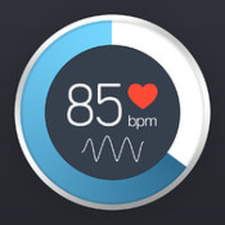  This FREE application provides a quick and easy way to tell if you are too upset to have an effective conversation with your partner (flooded) and/or could benefit from using some distress tolerance skills to bring down the intensity of your emotions. | DBT DIARY CARD AND SKILLS COACH  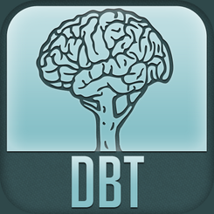  A handy application for DBT clients that allows you to create a customized diary card. As the application is on your phone, it increases the frequency and ease with which you can record relevant information. In addition, this app functions as a "skills coach," and recommends skills to try based on your needs. Cost: $4.99. | INSIGHT TIMER - MEDITATION TIMER  An invaluable tool for those who aim to deepen their practice. With 6 singing bowl sounds to choose from, this app allows you to set an alarm that can sound at intervals throughout your practice or at its conclusion. Cost: $2.99.

JKZ SERIES 1  John Kabat-Zinn's iphone app makes the trainings provided in his 8-week Mindfulness-Based Stress Reduction class available to anyone with a smart phone. His guided meditations include a sitting meditation, yoga, and body scan meditation. Each is about 45 minutes. If you are serious about establishing or developing a meditation practice, this is a must have! Cost: $3.99. | MOOD LOG  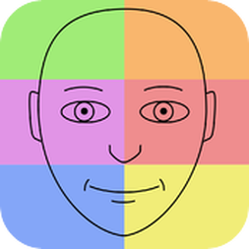  A simple and FREE way to monitor emotions across days, weeks, and months. For folks working on developing mindfulness of current emotions, or on their ability to regulate emotions, I highly recommend this application. | RELAXATION  An excellent resource for those new to Progressive Muscle Relaxation and/or deep breathing. There are options for guided and non-guided exercises. This FREE app isn't bogged down with a lot of unnecessary features, making it easy to use in a crisis or on the go.

LIVE OCD FREE  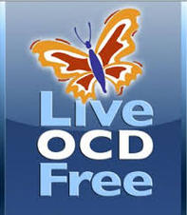  This is an EXCELLENT tool for individuals who are using Exposure and Response Prevention to treat obsessive-compulsive disorder. The app provides a nice compliment to the work we would be doing in session and provides clients with a quick and easy space in which to track and monitor treatment progress.  Cost: $29.99. | BREATHE 2 RELAX  A must have for anyone working on flooding, anxiety, or emotion regulation. This FREE app provides many customizable options for various breathing exercises. Regardless of whether you are a new or seasoned practitioner of deep breathing, this is an invaluable tool for establishing and sustaining your practice! | GOTTMAN INSTITUTE APPLICATIONS  The Gottman Institute provides a nice collection of applications to supplement the work you will be doing in couple's therapy. These apps are also straightforward enough to be used by folks who aren't in couple's therapy, but would like to improve the quality of their relationships. Cost: Free - $2.99.

